NEURAL NETWORKS AND DEEP LEARNING - 22ITE13
ACTIVITY-1
TOPIC: Student Study Hours
NAME: Swetha.S
CLASS: 23IT5B
REGISTER NO: 732923ITR111
PROGRAM:
import numpy as np
import matplotlib.pyplot as plt
from sklearn.linear_model import LinearRegression
hours = np.array([1, 2, 3, 4, 5]).reshape(-1, 1)
scores = np.array([50, 55, 60, 65, 70])
model = LinearRegression()
model.fit(hours, scores)
predicted = model.predict([[6]])
print("Predicted score for 6 hours =", predicted[0])
plt.scatter(hours, scores, color='blue', label='Actual Data')
plt.plot(hours, model.predict(hours), color='red', label='Regression Line')
plt.title("Hours vs Exam Score")
plt.xlabel("Hours Studied")
plt.ylabel("Score")
plt.legend()
plt.grid(True)
plt.show()
OUTPUT:
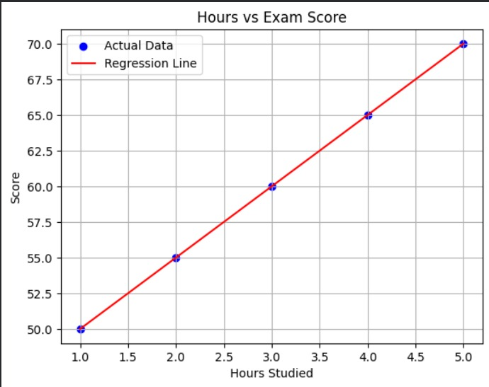
GITHUB LINK: https://github.com/swethasenthil30/NN-1.git

